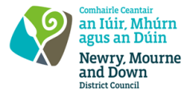
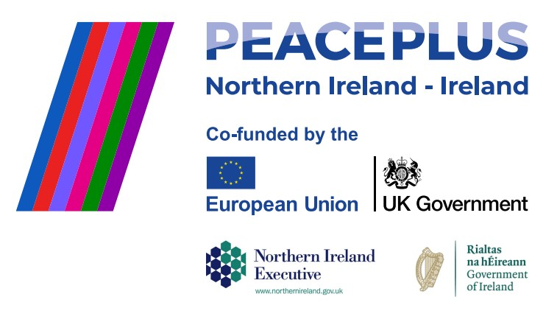
CA18552 RFQ 2026/40
NMANDD PEACEPLUS Thriving Together – Minority Community Support Programme - Journeys & Belonging

Competent consultancy companies are hereby invited to tender to design, develop and deliver a minority community support programme, that will be delivered across the Rowallane and Slieve Croob DEAs (District Electoral Areas). The programme will provide participants with an engaging opportunity to explore the stories of migration, emigration, identity and belonging that have shaped Northern Ireland and its communities over generations. Through a combination of interactive workshops, genealogy activities, and a cultural study visit, participants will examine the historical movements of people that have influenced language, traditions, culture and community life, while also reflecting on their own family histories and personal journeys.
To access this opportunity, log in to https://suppliers.multiquote.com and view the opportunity.
If you are not registered with MultiQuote, please visit https://suppliers.multiquote.com, complete the registration form on the log in page and quote the title and reference of the notice in your registration.

Signed: Mrs Marie Ward
Chief Executive
All relevant submissions to be received on or before 12 Noon 10/11/2026
A project supported by PEACEPLUS, a programme managed by the Special EU Programmes Body (SEUPB).

