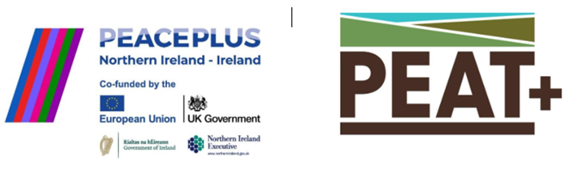
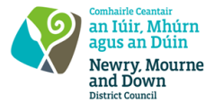

CA XXXXX RFQ: 2026/39
Supply and Installation of steel post and wire Fencing PEACEPLUS PEAT+
Competent suppliers are hereby invited to tender to for the supply and installation of fencing for the PEAT+ project. The project is supported by PEACEPLUS, a programme managed by the Special EU Programmes Body (SEUPB). PEAT+ is €19million cross-border peatland restoration project funded by PEACEPLUS, a programme managed by the Special EU Programmes Body (SEUPB).
The PEAT+ project, led by Ulster Wildlife in collaboration with 7 other cross-border partners, focuses on restoring peatlands across Northern Ireland and Ireland’s border counties. As part of PEAT+, Newry Mourne and Down District Council will be delivering conservation grazing on Killeavy estate, located within Slieve Gullion SAC. A robust and long-term fencing solution is required to implement successful conservation outcomes.
The site is underlain with peaty soils of varying depths. The ground is uneven, slippery when wet, highly compressible with low shear strength, and prone to erosion in extreme weather events.
Slieve Gullion is designated as a Special Area of Conservation (SAC) due to the presence of rare habitat, protected species and unique geology. Prospective tenderers must ensure that environmental disturbance is minimised and relevant environmental regulations are met throughout the project.
To access this opportunity, log in to https://suppliers.multiquote.com and view the opportunity.
If you are not registered with MultiQuote, please visit https://suppliers.multiquote.com, complete the registration form on the log in page and quote the title and reference of the notice in your registration.
Signed: Mrs Marie Ward
Chief Executive
All relevant submissions to be received on or before 12 Noon on 29 October 2026.
The PEAT+ Project is led by local nature conservation charity Ulster Wildlife and is funded by PEACEPLUS, a programme managed by the Special EU Programmes Body (SEUPB) with delivery partners:

