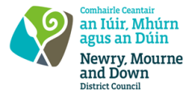
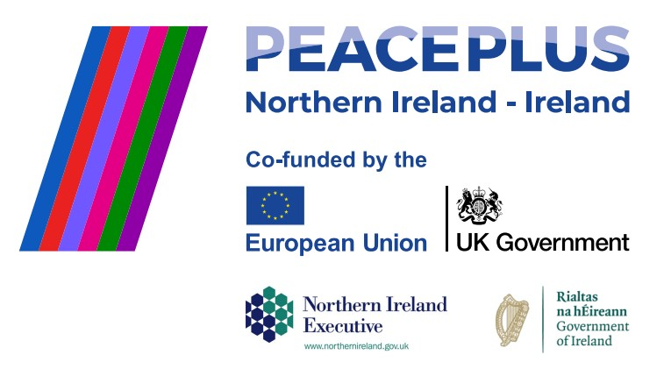

CA18515 RFQ 2026/38
NMANDD PEACEPLUS Thriving Together - Shared History & Culture Programme - Hanna's Close
Competent consultancy companies are hereby invited to tender to design, develop and deliver a shared history and culture programme that will increase participants’ knowledge and understanding of individual, family and collective history through the exploration of Hanna’s Close, a preserved Ulster-Scots clachan (settlement) in Aughnahoory, Kilkeel. The programme will place a particular emphasis on genealogy; tracing family connections linked to Hanna’s Close and examining patterns of emigration from the settlement. Participants will explore how generations of local families established new lives across the world and consider the social, economic and cultural impact these individuals and their descendants have had on communities both locally and internationally.

To access this opportunity, log in to https://suppliers.multiquote.com and view the opportunity.
If you are not registered with MultiQuote, please visit https://suppliers.multiquote.com, complete the registration form on the log in page and quote the title and reference of the notice in your registration.
Signed: Mrs Marie Ward
Chief Executive
All relevant submissions to be received on or before 12 Noon 29/10/2026.
A project supported by PEACEPLUS, a programme managed by the Special EU Programmes Body (SEUPB).

