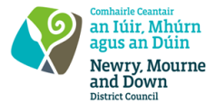
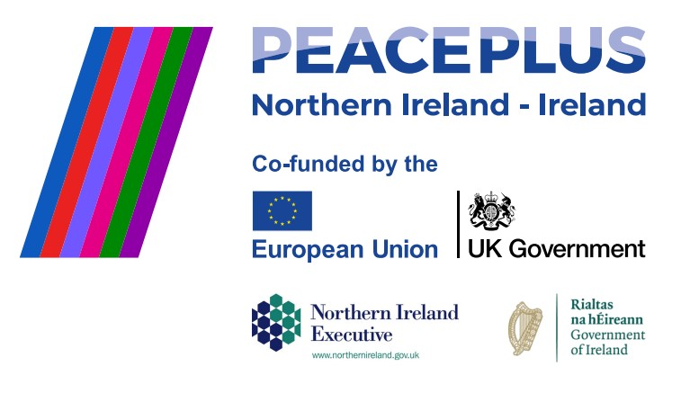
CA18475 - RFQ REF: 2026/35
NMANDD PEACEPLUS Mourne Film Festival Project - Rural Women’s Voices.
Competent Consultancy companies are hereby invited to tender to design, develop and deliver NMANDD PEACEPLUS Mourne International Film Festival Project; Rural Women’s Voices. The aim is to deliver and design a community-led creative programme empowering women from the Mourne DEA (District Electoral Area) to develop their voices through creative writing and filmmaking culminating in a 20-minute original film created by participants that will be premiered at an International Film Festival celebrating Rural Women in the week of International Women’s Day 8th March 2027. The women will plan the film festival selecting films that reflect the lives of rural women around the world. This project aims to amplify underrepresented rural women’s stories, connecting local experiences with global perspectives.
To access this opportunity, log in to https://suppliers.multiquote.com and view the opportunity.
If you are not registered with MultiQuote, please visit https://suppliers.multiquote.com, complete the registration form on the log in page and quote the title and reference of the notice in your registration.
Signed: Mrs Marie Ward
Chief Executive
All relevant submissions to be received on or before 12Noon on 14 October 2026.
A project supported by PEACEPLUS, a programme managed by the Special EU Programmes Body (SEUPB).

