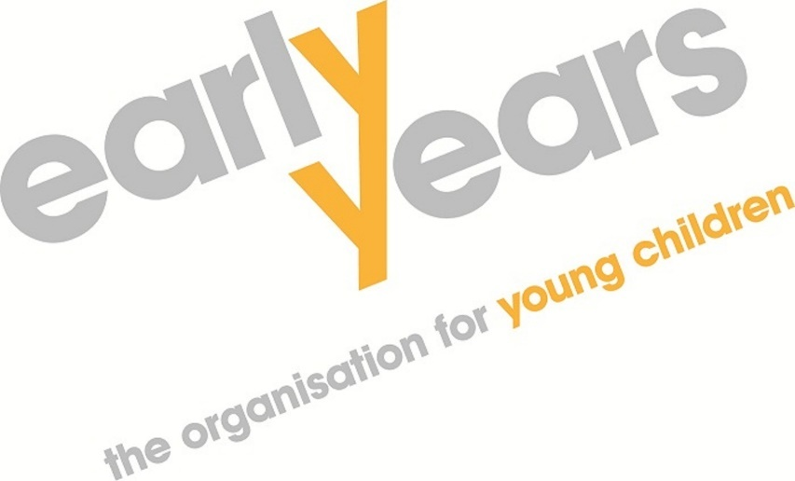

Pre-Market Engagement
Request for Information (RFI)

Supply of a Digital Portal
To design, develop, implement, and support a digital portal to administer the Northern Ireland Childcare Subsidy Scheme

CONTENTS
Introduction 3
Queries 3
Timetable 3
Submission Process 3
General 3
Objectives 4
Background 4
Scope of Work 4
APPENDIX I: Response Document 9

Introduction
Early Years – the organisation for young children, is currently preparing to initiate a procurement process to establish a contract with a supplier for the design, development, implementation and support of a replacement digital portal to administer the Northern Ireland Childcare Subsidy Scheme.
Prior to commencing the procurement process, Early Years seeks to explore the level of market interest and obtain feedback on the proposed requirements through this Pre-Market Engagement Request for Information (RFI) exercise.
Queries
This process represents an initial exploratory stage and has no relevance in terms of future procurement selection processes. Early Years will not enter into detailed discussion of the requirements, price and other commercial aspects at this stage.
Any questions about the process should be submitted by e-mail to: tenders@early-years.org.
Please use Reference: RFI102 when emailing with regards to this RFI.
Timetable
Responses should be submitted by the 2nd of October, 2026, 4pm.
Submission Process
Responses should be sent via email to: tenders@early-years.org.
Please use Reference: RFI102 when emailing your response to this RFI.
General
Early Years will not reimburse any expense incurred in preparing the responses to the RFI.
Responding to this RFI does not represent a prerequisite for any eventual procurement process and it will not influence any procurement selection process.
Responses to this document will not form part of any formal evaluation process and will be used for information only. Any subsequent procurement activity will be in accordance with the relevant procurement procedures.
Early years reserves the right to retain all non-confidential submission material for internal purposes.
The issue of this RFI does not commit Early Years or the respondent in any way, nor does it constitute an offer to enter into a contractual relationship.
The responses to this RFI in no way influence the outcome of any eventual subsequent procurement process. Early Years may not decide to undertake for this service nor does it constitute a pre-qualification questionnaire or any other procurement process documentation.
Objectives
This exercise will be used to assist Early Years in gaining a better understanding of the feasibility of the requirements, the most appropriate procurement and operational approach and the capacity of the market to deliver the requirements.
The specific objectives of this exercise are to:
- Understand the range of suitable solutions and delivery models available in the market.
- Test the feasibility of the requirements and proposed implementation timeline.
Understand likely implementation, hosting, licensing, support and change costs.
- Identify opportunities to simplify processes, improve user experience and reduce ongoing supplier dependency.
- Identify key risks, dependencies and assumptions Early Years should consider before procurement.
- Understand the budgetary requirements to support the procurement process.
Background
The Northern Ireland Childcare Subsidy Scheme (NICSS) is administered by Early Years on behalf of the Department of Education. The scheme supports eligible working parents through a childcare subsidy and is delivered through registered childcare providers and schools.
The current system supports approximately 18,000 parents, 24,000 children and 2,000 providers, with approximately 22,000 child claims per month. The replacement portal is intended to provide a secure, modern, accessible and scalable solution supporting parents, providers and Early Years staff.
Scope of Work
The replacement system must facilitate the efficient administration of childcare subsidy payments, including applicant registration, eligibility assessment, application processing, childcare provider management, payment administration, reporting, audit, and customer support functions. The system must support the needs of multiple user groups, including parents and carers, childcare providers, scheme administrators, and relevant government stakeholders.
The solution should improve operational efficiency, reduce manual intervention, enhance data quality and governance, strengthen security and fraud prevention controls, and provide a positive digital experience for users. It should also be capable of adapting to future policy, legislative, and operational changes, with minimal disruption and cost.
The minimum requirements for the digital portal are outlined in the following sub-sections.
Functional Requirements
The proposed solution must provide, as a minimum, the following core functions to support the end-to-end administration of the Northern Ireland Childcare Subsidy Scheme (NICSS).
User Registration and Authentication
- Secure registration and account management for parents, childcare providers and scheme administrators.
- Multi-factor authentication and password management capabilities.
- Role-based access controls.
- User profile management and account recovery functions.

Parent and Child Application Management
- Online application submission and management.
- Ability to upload and manage supporting documentation.
- Automated validation of mandatory fields and eligibility criteria.
- Application status tracking and notifications.
- Secure messaging between applicants and administrators.

Eligibility Assessment
- Automated eligibility checking based on scheme rules.
- Support for manual review and decision-making where required.
- Recording of eligibility decisions and rationale.
- Ability to accommodate future policy changes without significant redevelopment.

Childcare Provider Management
- Registration and maintenance of childcare provider information.
- Verification and approval workflows.
- Management of provider eligibility and participation status.
- Secure update of provider details.

Payment Administration
- Calculation and administration of childcare subsidy payments.
- Payment approval workflows.
- Management of payment schedules, adjustments, overpayments and repayments.
- Complete audit trail of all payment transactions.

Case Management
- Workflow management for scheme administrators.
- Allocation and tracking of cases.
- Recording of notes, actions and correspondence.
- Escalation and exception handling processes.

Communications and Notifications
- Automated notifications via email and/or SMS.
- User alerts regarding application progress and actions required.
- Template management for correspondence.
- Secure messaging capabilities.

Reporting and Management Information
- Standard operational and performance reports.
- Real-time dashboards for scheme monitoring.
- Export of data in commonly used formats (e.g. Excel, CSV).
- Ad hoc reporting capability for authorised users.
- Reporting on applications, eligibility, payments, providers and scheme performance.

Audit, Compliance and Security
- Comprehensive audit logging of all user activity and system changes.
- Data retention and archival capabilities.
- GDPR-compliant data management (legislation including the UK GDPR and Data Protection Act 2018)
- Fraud detection and prevention controls.
- Cyber security controls aligned with government standards.

Accessibility and User Experience
- Compliance with WCAG 2.2 AA accessibility standards.
- Responsive design for desktop, tablet and mobile devices.
- Plain English content and intuitive navigation.
- User-centred design principles to minimise administrative burden.
- Be easy to use for people with varying levels of digital confidence.

System Administration
- Configuration management tools for authorised administrators.
- User and role management.
- Workflow and business rule configuration.
- Monitoring, performance management and system health reporting.

Supportability
- In addition to the Production environment, Suppliers should also provide relevant non-production environments for development, testing and support processes (minimum of 2 in addition to Live).
- External User Emulation Capability

Non-Functional Requirements
Hosting requirements
Suppliers must provide suitable hosting for the new system, to meet both implicit and explicit functional and non-functional characteristics outlined.
It should be hosted compliantly for a UK-based user base.
Availability
The system must be routinely available Monday to Friday, including Bank Holidays during the hours of 9.00 – 5.00 on the basis of 99% availability.
Outside those hours should be on the basis of 99% availability.
Back-Up / Recovery Requirements
The supplier must ensure provision for backups of production environment on a regular basis to prevent data loss, with a worst-case scenario of 24 hours.
Suppliers will be required to evidence fail-over / recovery as part of initial system acceptance and annual service management thereafter to demonstrate suitable Recovery Time Objective (RTO) and Recovery Point Objective (RPO).
Scalability
It is possible that in the coming years, NICSS will expand in terms of children and providers and the discount rate may increase.
For planning purposes, suppliers should assume a possible growth of 50% in demand, for example:
- from 20,000 to 30,000 children on the scheme per year
- from 20,000 to 30,000 claims per month
- from 20,000 TFC renewals to 30,000 TFC renewals once per quarter
Archival
It is the expectation that the system should be capable of holding 7 years data online (out to 2032), without the need for archival of data due to performance reasons.
Equally, it is anticipated that it should be possible to archive / remove certain document images which are more than a certain age, and are no longer required to be accessed.

Maintainability – EY vs Supplier
Early Years wish to be as self-reliant as possible in managing and maintaining the operation of the replacement system, without undue recourse to the supplier.

Training & Support
As part of the development of the Portal, it is anticipated that adequate training and onboarding materials be developed, including:
- User guides (simple, short)
- Short introductory videos
- Optional live demos
- Easy-to-follow admin instructions for Early Years staff
- More advanced training for technical admin team
- Designated contact for support from supplier

APPENDIX I

Pre-Market Engagement
Request for Information (RFI)

Supply of a Digital Portal
To design, develop, implement, and support a digital portal to administer the Northern Ireland Childcare Subsidy Scheme

RESPONSE DOCUMENT

Deadline
Responses should be submitted by the 2nd of October, 2026, 4pm.

Submission Process
Responses should be sent via email to: tenders@early-years.org.
Please use Reference: RFI102 when emailing your response to this RFI.

Please complete all questions as accurately and concisely as possible.
Organisation Details
Name and Address:
Please provide the name, address and contact details for your organisation:
Organisation:

Address:

Contact Name: | Email:
Phone: | Web Site:

General overview of your company’s relevant activities:

1 . Proposed Solution
Please provide a brief overview of your proposed solution and explain how it would meet the main NICSS requirements. Please identify any requirements you believe should be approached differently or simplified.

2. Delivery Approach
Please describe your proposed approach to discovery, design, development, testing, pilot and rollout. Please provide an indicative timeline and identify the Early Years resources/dependencies you would require.

3. User Experience and Accessibility
How would you design a platform for parents and small childcare providers who may have limited digital confidence, while also supporting larger providers processing claims in volume? Please explain your approach to WCAG 2.2 AA and usability testing.

4. Technical Architecture and Hosting
Please outline your proposed architecture, technology stack, hosting model and environments.

5. Data Migration
Please describe your approach to migrating the existing NICSS data, including structured data and relevant documents. Please explain how you would validate migration, manage data quality issues and handle records that do not map cleanly?

6. Integrations and Payments
Please identify any integrations you would expect to use or recommend, including email/SMS, address data, financial systems/BACS and any relevant external services. Please state which integrations are included in your indicative pricing.

7. Support & Service Management
Please describe your proposed support model, service hours, incident priorities, response/resolution targets, monitoring, maintenance and release management. Please state what is included in annual support.

8. Key Risks and Recommendations
Please identify any significant risks or challenges you foresee in delivering this solution and provide your recommended mitigations. Please also identify any requirements you believe Early Years should clarify before issuing a tender.

Indicative Costings
Please provide indicative pricing only at this stage. Early Years is not seeking a binding quotation but would like to gain a fuller understanding of anticipated costs to further support the formal procurement process.
Cost Area | Indicative Cost (inc. VAT) | Key Assumptions / Notes
Discovery and Design
Implementation / Delivery
Data Migration
Hosting / Infrastructure
Licensing / Subscriptions (per Annum)
Annual support
Additional Integrations (Optional as per Q6)
Change / Development day rates
Estimated Year 1 Total

