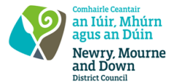
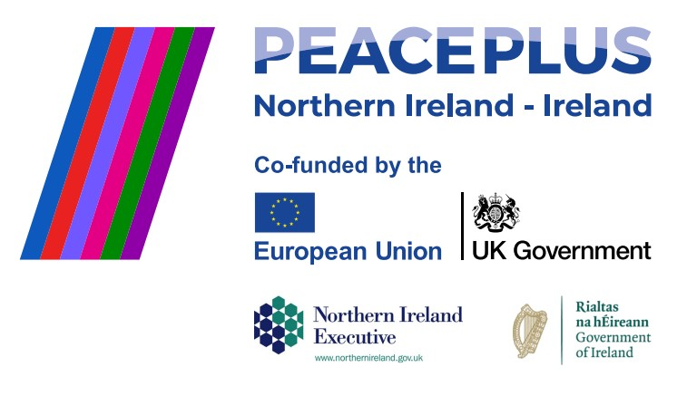

CA18452 - RFQ 2026/34
NMANDD PEACEPLUS Thriving Together – Cross Communities Festival Programme; Building Bridges, Connecting Communities for the Newry, Mourne and Down District Council area
Competent consultancy companies are hereby invited to tender to design, develop and deliver a comprehensive cultural, heritage and community engagement programme, marking the development of the new Narrow Water Bridge, which is due to open in 2027. The programme aims to celebrate shared heritage, strengthen cross-community relationships, and create a lasting legacy through creative participation and public celebration.
To access this opportunity, log in to https://suppliers.multiquote.com and view the opportunity.
If you are not registered with MultiQuote, please visit https://suppliers.multiquote.com, complete the registration form on the log in page and quote the title and reference of the notice in your registration.
Signed: Mrs Marie Ward
Chief Executive
All relevant submissions to be received on or before 12 Noon on Thursday 08 October 2026.
A project supported by PEACEPLUS, a programme managed by the Special EU Programmes Body (SEUPB).

