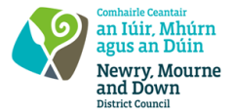
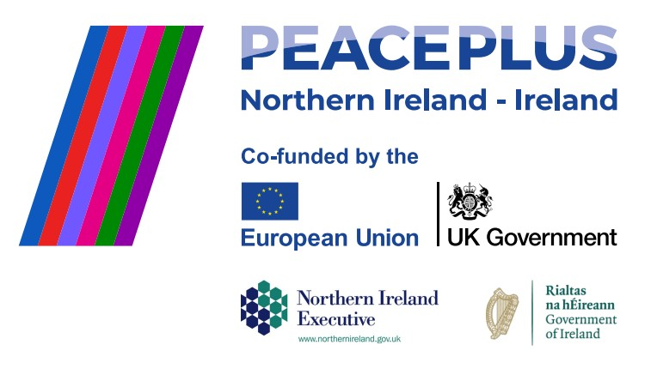
CA18415 - RFQ REF: 2026/33
NMANDD PEACEPLUS Thriving Together
PEACEPLUS 3.2 Creative Cultures After school

Competent consultancy organisations are invited to tender for the design and delivery of a culturally focused integration programme for Key Stage 3 pupils in the Slieve Croob DEA. This initiative will bring together young people from diverse cultural backgrounds, including those from minority ethnic communities, to promote inclusion, intercultural understanding and positive relationships.
Through a series of creative workshops, cultural exchange activities and collaborative projects, participants will engage in shared learning experiences that celebrate diversity and explore different cultural perspectives. Using dance, music and creative expression as tools for engagement, the programme will provide a safe and inclusive space for young people to explore cultural identity, challenge prejudice, develop confidence and build meaningful connections with their peers.
To access this opportunity, log in to https://suppliers.multiquote.com and view the opportunity.
If you are not registered with MultiQuote, please visit https://suppliers.multiquote.com, complete the registration form on the log in page and quote the title and reference of the notice in your registration.
Signed: Mrs Marie Ward
Chief Executive
All relevant submissions to be received on or before 12 Noon on Thursday 01 October 2026.
A project supported by PEACEPLUS, a programme managed by the Special EU Programmes Body (SEUPB).

