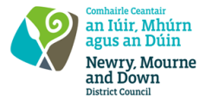
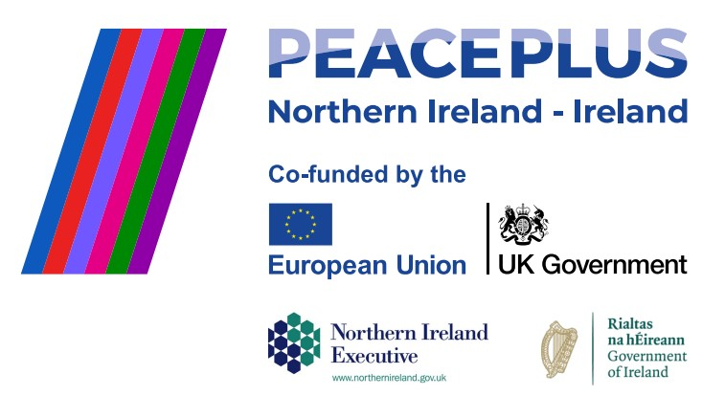
CA18364 - Tender 56/2026 - NMANDD PEACEPLUS
Thriving Together - Community Justice - Youth Intervention Programme Impact: Choices and Consequences
NMDDC seeks to appoint an experienced provider to design and deliver a district-wide behaviour-change programme for young adults aged 18–24. The programme will use interactive drama, scenario-based learning, and a professionally produced documentary film to explore choices, consequences, antisocial behaviour, and the criminal justice system.
The programme aims to:

- Increase awareness of the impact of antisocial behaviour.
- Improve decision-making and understanding of consequences.
- Challenge attitudes and support positive behaviour change.
- Provide a legacy resource (the documentary film) for ongoing use in schools, youth clubs, colleges, and community settings.

To access this opportunity, log in to https://suppliers.multiquote.com and view the opportunity. If you are not registered with
MultiQuote, please visit https://suppliers.multiquote.com, complete the registration form on the log in page and quote the title and reference of the notice in your registration.
Signed: Mrs Marie Ward
Chief Executive
All relevant submissions to be received on or before 12 Noon Wednesday 30 September 2026.
A project supported by PEACEPLUS, a programme managed by the Special EU Programmes Body (SEUPB).”

