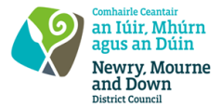
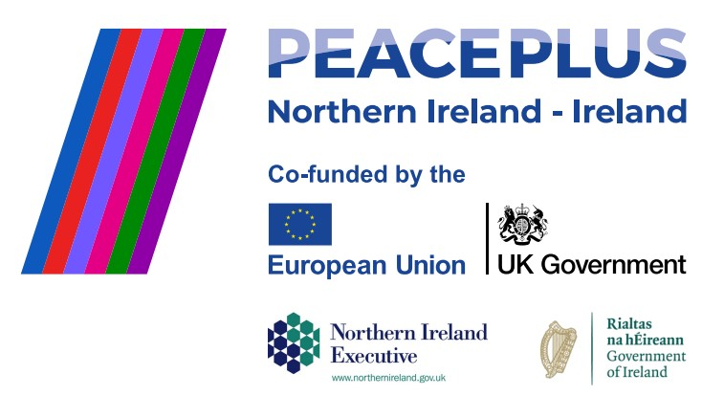
CA18346 - Tender Ref: 54/2026
NMANDD PEACEPLUS Thriving Together 3.6 United through Play and Expression.
Competent and creative suppliers are hereby invited to tender for the design, development, and delivery of a Responsive Peace Building Programme for young people aged 12–18 years.
The programme will provide safe and supportive spaces for young people to explore challenging political and social issues through dialogue, learning, and community engagement. It will promote greater understanding and respect for diverse identities while strengthening cross-community, cross-border, and intergenerational relationships.
Using innovative, activity-based approaches, the programme will engage participants through local sports clubs, youth groups, and community settings. Particular emphasis should be placed on increasing participation from minority and marginalised communities through targeted outreach and support.
The programme should foster reconciliation, shared learning, inclusion, and a sense of belonging by encouraging participants to explore identity, history, and shared narratives. Creative proposals are sought that deliver meaningful peacebuilding outcomes and contribute to stronger, more connected communities.
To access this opportunity, log in to https://suppliers.multiquote.com and view the opportunity. If you are not registered with MultiQuote, please visit https://suppliers.multiquote.com, complete the registration form on the log in page and quote the title and reference of the notice in your registration.

Signed: Mrs Marie
Ward Chief Executive
All relevant submissions to be received on or before 12 Noon on Thursday 10 September 2026.
A project supported by PEACEPLUS, a programme managed by the Special EU Programmes Body (SEUPB).

