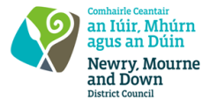
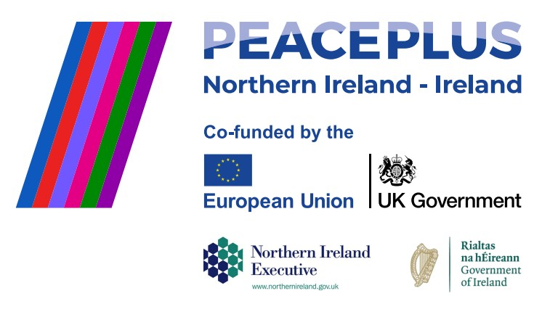
CA18311 Tender 46/2026 – NMANDD PEACEPLUS
UNESCO Together Project – PEACEPLUS 6.2 Integrated Facilitation, Residential Coordination, Accommodation, Transport and Strategic Reporting Services

Newry, Mourne and Down District Council (NMDDC), invites tenders from suitably qualified and experienced organisations to deliver an integrated programme of facilitation, residential coordination, accommodation management, transport coordination, engagement support, evaluation, and strategic reporting for the UNESCO Together Project.
UNESCO Together is a cross-border, community-focused initiative connecting UNESCO-designated sites across the island of Ireland including UNESCO Global Geoparks, World Heritage Sites, Biosphere Reserves, and Creative Cities.
The project is funded under the PEACEPLUS Programme Investment Area 6.2 and seeks to foster reconciliation, peacebuilding, and cross-border cooperation through shared heritage, culture, storytelling, environmental action, and sustained people-to-people engagement.
The contract requires a single supplier to design, coordinating, deliver, monitoring and reporting on a fully integrated programme of engagement activities and associated logistical support across the island of Ireland. The supplier shall act as the prime contractor and shall retain full responsibility for the delivery of the contract.
To access this opportunity, log in to https://suppliers.multiquote.com and view the opportunity.
If you are not registered with MultiQuote, please visit https://suppliers.multiquote.com, complete the registration form on the log in page and quote the title and reference of the notice in your registration.

Signed: Mrs Marie Ward
Chief Executive
All relevant submissions to be received on or before 12noon 01/09/2026
A project supported by PEACEPLUS, a programme managed by the Special EU Programmes Body (SEUPB).

