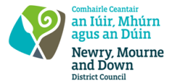
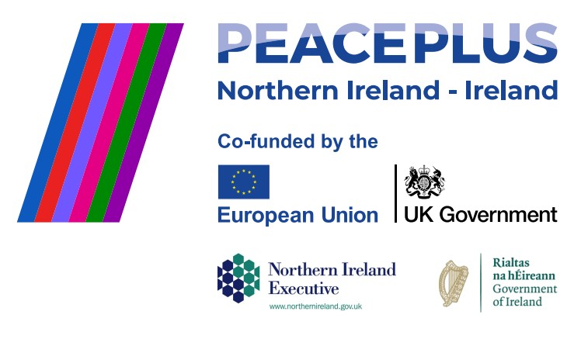
RFQ REF: 2026/26
NMANDD PEACEPLUS 3.5 Farmers Festival

Competent and creative suppliers are hereby invited to tender for the design, development, and delivery of an engaging festival programme for the upcoming Farmers Festival in the Crotlieve DEA.
This initiative will deliver a celebratory, educational, and participant-led project that promotes greater understanding, appreciation, and respect for cultural identities, traditions, and rural heritage within the local community.
Through a programme of interactive workshops, shared learning experiences, and community engagement activities, participants will explore aspects of local culture, farming traditions, and rural life while building connections across diverse backgrounds.
The programme will culminate in an inclusive Diversity Festival celebrating culture, heritage, and community spirit. We seek creative proposals that foster participation, learning, inclusion, and community cohesion across the Crotlieve area.
To access this opportunity, log in to https://suppliers.multiquote.com and view the opportunity. If you are not registered with MultiQuote, please visit https://suppliers.multiquote.com, complete the registration form on the log in page and quote the title and reference of the notice in your registration.
Signed: Mrs Marie Ward
Chief Executive
All relevant submissions to be received on or before 12 Noon Tuesday 25 August 2026.
A project supported by PEACEPLUS, a programme managed by the Special EU Programmes Body (SEUPB).

