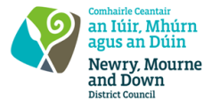
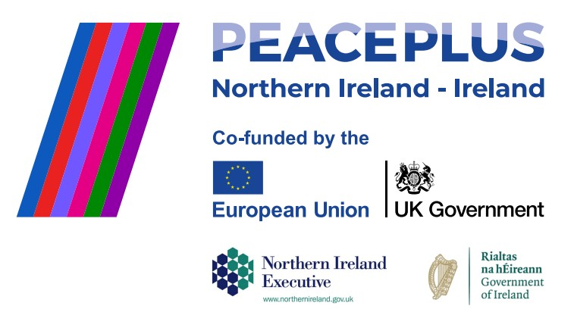CA18276 - RFQ REF: 2026/25
NMANDD PEACEPLUS Thriving Together Celebrating Cultures and Diversity 3.5 Sports Festival
Competent and creative suppliers are invited to tender for the design, development, and delivery of a two-stage Inclusive Sports Programme.
Stage 1 will consist of a series of inclusive, locally based sports workshops and a site visit designed to build the skills, knowledge, and confidence of sports clubs, coaches, and community organisations to support the participation of people with disabilities in sport. These capacity-building activities will provide participants with practical tools and experience to create accessible, welcoming, and sustainable sporting environments.
Stage 2 will culminate in a large-scale Inclusive Sports Festival on International Day of Persons with Disabilities. The festival will provide free and accessible opportunities for workshop participants and the wider public to experience adapted sports, engage with local clubs and organisations, and learn about opportunities for ongoing participation in sport across the district.
Through both stages, the programme aims to increase understanding of disability inclusion, strengthen inclusive practice within local sporting organisations, expand participation opportunities for people with disabilities, and contribute to stronger, more connected communities across the district.
To access this opportunity, log in to https://suppliers.multiquote.com and view the opportunity. If you are not registered with MultiQuote, please visit https://suppliers.multiquote.com, complete the registration form on the log in page and quote the title and reference of the notice in your registration.
Signed: Mrs Marie Ward
Chief Executive
All relevant submissions to be received on or before 12 Noon 21 August 2026
A project supported by PEACEPLUS, a programme managed by the Special EU Programmes Body (SEUPB).

