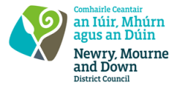
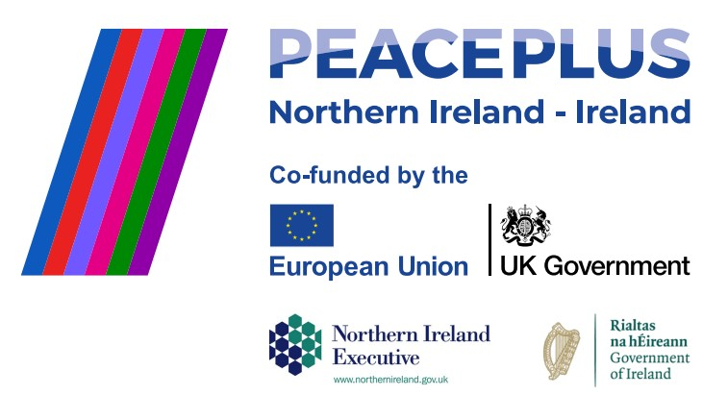

RFQ 2026/24
NMANDD PEACEPLUS Thriving Together–Minority Community Support Programme: Sports for All for the Newry, Mourne and Down District Council area.
Competent consultancy companies are hereby invited to tender to design, develop and deliver a minority community support programme. This project will engage a skilled inclusive sports facilitator to support children with disabilities to participate in a diverse range of accessible sports and recreational activities. The programme will take a holistic approach, using sport, creative play, and outdoor experiences to promote integration, orientation, and wellbeing among children from minority communities.
To access this opportunity, log in to https://suppliers.multiquote.com and view the opportunity.
If you are not registered with MultiQuote, please visit https://suppliers.multiquote.com, complete the registration form on the log in page and quote the title and reference of the notice in your registration.
Signed: Mrs Marie Ward
Chief Executive
All relevant submissions to be received on or before 12 Noon on Tuesday 18 August 2026.
A project supported by PEACEPLUS, a programme managed by the Special EU Programmes Body (SEUPB).

