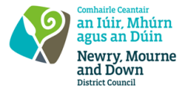
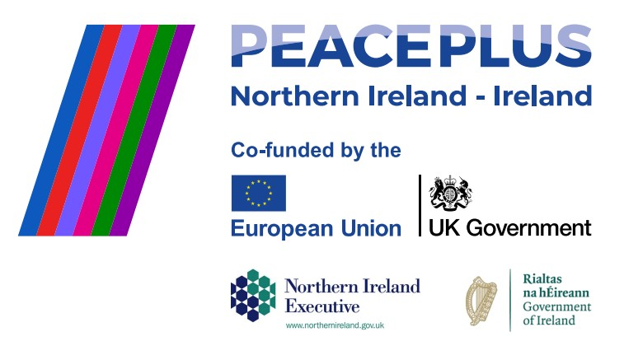

CA18207 RFQ 2026/20 – NMANDD PEACEPLUS

PEACEPLUS 3.2 Food and Friendship Culinary Exchange

Competent suppliers are invited to tender for the design and delivery of a culturally focused integration programme centred on shared culinary experiences. This project will engage participants from minority ethnic and local communities across the Newry, Mourne and Down area through interactive cooking workshops, cultural storytelling, and guided visits to local food suppliers.
Participants will work alongside local home cooks from diverse backgrounds to prepare traditional dishes while exploring the cultures, experiences, and stories behind them. The programme will promote intercultural understanding, challenge stereotypes, and encourage discussions on inclusion.
To access this opportunity, log in to https://suppliers.multiquote.com and view the opportunity.
If you are not registered with MultiQuote, please visit https://suppliers.multiquote.com, complete the registration form on the log in page and quote the title and reference of the notice in your registration.

Signed: Mrs Marie Ward
Chief Executive
All relevant submissions to be received on or before 12noon on 06/08/2026
A project supported by PEACEPLUS, a programme managed by the Special EU Programmes Body (SEUPB).

