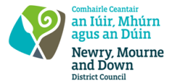
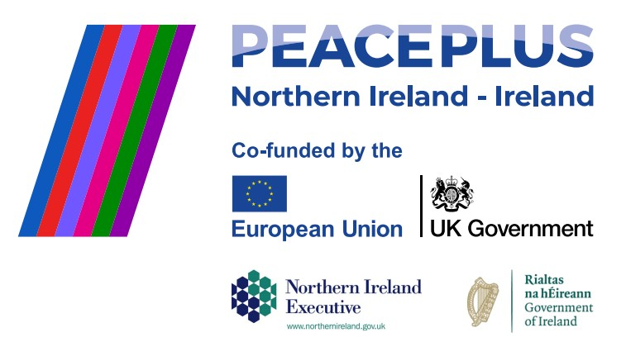

CA18200 - RFQ REF: 2026/23
NMANDD PEACEPLUS 3.2 Nature and Wellness Walks

Competent consultancy organisations are invited to tender for the design and delivery of a culturally focused integration programme centred on a series of guided, family-friendly nature and wellbeing walks. This project will engage participants from minority ethnic and local communities across to explore local parks, greenways, coastal areas and heritage sites. These shared outdoor experiences will promote social connection, reduce isolation, and foster a sense of belonging, while supporting positive wellbeing.
By creating safe, inclusive and welcoming spaces, the programme will strengthen relationships across communities, promote intercultural understanding, and support participants to become active and confident members of their local community.
To access this opportunity, log in to https://suppliers.multiquote.com and view the opportunity.
If you are not registered with MultiQuote, please visit https://suppliers.multiquote.com, complete the registration form on the log in page and quote the title and reference of the notice in your registration.
Signed: Mrs Marie Ward
Chief Executive
All relevant submissions to be received on or before 12 Noon on Wednesday 05 August 2026.
A project supported by PEACEPLUS, a programme managed by the Special EU Programmes Body (SEUPB).

