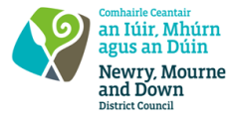
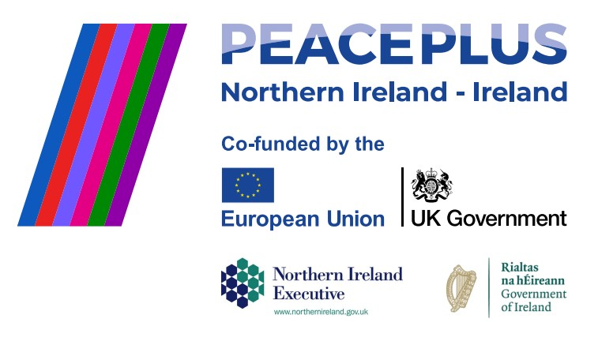
RFQ REF: 2026/22
NMANDD PEACEPLUS Thriving Together
PEACEPLUS 3.2 Women in Farming.

Competent consultancy organisations are invited to tender for the design and delivery of a culturally focused integration programme supporting women in farming. This initiative will bring together women from diverse and underrepresented backgrounds who are living in, working in, or connected to farming and rural life across the Slieve Gullion DEA area.
Through a series of interactive workshops, practical demonstrations and farm-based experiences, participants will engage in a culture swap, sharing knowledge, practices and lived experiences of agriculture, diversification and rural life. The programme will create a supportive space for women to explore cultural identity within farming, build skills and confidence, and strengthen peer connections
To access this opportunity, log in to https://suppliers.multiquote.com and view the opportunity.
If you are not registered with MultiQuote, please visit https://suppliers.multiquote.com, complete the registration form on the log in page and quote the title and reference of the notice in your registration.
Signed: Mrs Marie Ward
Chief Executive
All relevant submissions to be received on or before 12 Noon on Friday 31 July 2026.
A project supported by PEACEPLUS, a programme managed by the Special EU Programmes Body (SEUPB).

