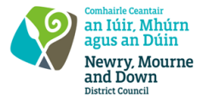
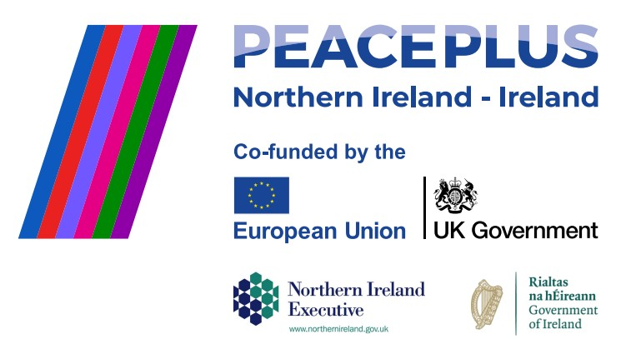

RFQ 2026/21
NMANDD PEACEPLUS Local Action Plan Thriving Together
From Tradition to Tomorrow, Rural Men’s Skills Exchange – Rowallane DEA
Competent consultancy companies are hereby invited to tender to design, develop and deliver From Tradition to Tomorrow: Rural Men’s Skills Exchange - Rowallane DEA. This project will bring together rural men from the Rowallane DEA working in and alongside home industries, such as farming, food production and land management, to share past best practices and promote the adoption of sustainable and environmentally friendly future practices.
To access this opportunity, log in to https://suppliers.multiquote.com and view the opportunity.
If you are not registered with MultiQuote, please visit https://suppliers.multiquote.com, complete the registration form on the log in page and quote the title and reference of the notice in your registration.
Signed: Mrs Marie Ward
Chief Executive
All relevant submissions to be received on or before 12 Noon Wednesday 29 July 2026.
A project supported by PEACEPLUS, a programme managed by the Special EU Programmes Body (SEUPB).

