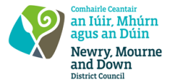
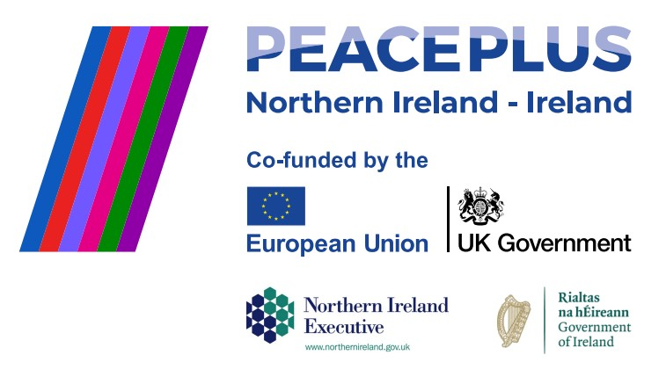

CA18126 RFQ 2026/16 - NMANDD PEACEPLUS
Thriving Together - Woven Through Time - Exploring the Shared Heritage of Bessbrook

Competent consultancy companies are hereby invited to tender to design, develop and deliver a structured programme celebrating the history and industrial heritage of Bessbrook. The programme will include a series of expert-led talks and workshops promoting understanding of shared heritage across communities and encouraging reflection on how industrial heritage shapes identity. Participants will take part in a guided historical walking tour of Bessbrook, a relevant study visit and a practical weaving workshop.
To access this opportunity, log in to https://suppliers.multiquote.com and view the opportunity.
If you are not registered with MultiQuote, please visit https://suppliers.multiquote.com, complete the registration form on the log in page and quote the title and reference of the notice in your registration.

Signed: Mrs Marie Ward
Chief Executive
All relevant submissions to be received on or before 12 Noon 23 July 2026
A project supported by PEACEPLUS, a programme managed by the Special EU Programmes Body (SEUPB).

