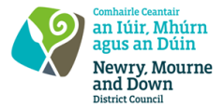
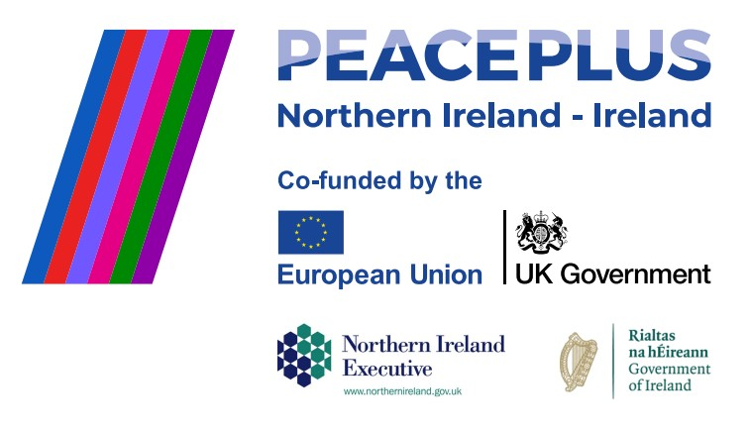
TENDER REF: 41/2026
NMANDD PEACEPLUS Thriving Together Social and Emotional Support Programmes. Rhythm Across Generations, for the Newry, Mourne and Down District Council area.
Competent consultancy companies are hereby invited to tender to design, develop and deliver a Social and Emotional Intergenerational Support programme, focusing on music and dance.
This project will deliver 7 intergenerational Music and Dance programmes, delivered across the Council area with one per District Electoral Area (DEA). The programme with include interactive workshops exploring how music and dance have changed and evolved through recent history and an end of programme celebration event such as a tea dance or music concert.

To access this opportunity, log in to https://suppliers.multiquote.com and view the opportunity.
If you are not registered with MultiQuote, please visit https://suppliers.multiquote.com, complete the registration form on the log in page and quote the title and reference of the notice in your registration.
Signed: Mrs Marie Ward
Chief Executive
All relevant submissions to be received on or before 12noon 21 July 2026.
A project supported by PEACEPLUS, a programme managed by the Special EU Programmes Body (SEUPB).

